Какво е качество – удовлетвореността на потребителя от продукта – да изпълнява точно това което очаква потребителя или product owner-a.

Функционално и не функционално

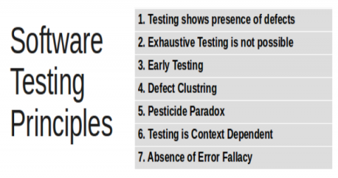

Author: [dkrishna](http://programsbuzz.com/user/2) on Sun, 04/22/2018 - 03:48

Over the period of time several Testing principles were suggested and out of those 7 has been considered.

**1. Testing Shows presence of defects, not their absence:** Bugs are always in Software, no Software is bug free. Testing reduce probability of undiscovered defects. If Testers are not able to find any defect it does not mean Software is bug free.

**2. Exhaustive testing is impossible:** Test for all combinations of inputs and preconditions is impossible except for trivial cases. So, instead of doing the exhaustive testing we can use risks and priorities to focus testing efforts. Unless the application under test has a very simple logical structure and limited input, it is not possible to test all possible combinations of data and scenarios.

**3. Early Testing saves time and money:** Testing activities should be started as early as possible in SDLC. Testing team should be involved in the project from the beginning. Important point about early testing is that when defects are found earlier in the life cycle, they are much easier and cheaper to fix. Early testing sometimes refereed to as shift left.

**4. Defect Clustering together:** A small number of modules contain most of the defects discovered during pre-release testing or show the most operational failure. This is the application of the Pareto Principle to software testing: approximately 80% of the problems are found in 20% of the modules.

Defects are not evenly distributed; they cluster together. If many defects are detected at one place, there is possibility that more defects would be there.

**5. Beware of the Pesticide Paradox:** Test cases need to be regularly reviewed and revised. If the same tests are repeated over and over on same release it will not find any defect and loose its effectiveness.

**6. Testing is context dependent:** For different type of Software testing is not same. Banking and E-Commerce Software are tested different than Safety critical Software.

**7. Absence of errors is a fallacy:** If the system built is unusable and does not fulfill the user's needs and expectations then finding and fixing defects does not help. If the product does not meet user's requirements explicitly mentioned and implicitly implied, that is if it is not fit for use, there is no point in testing, finding defects and fixing it.

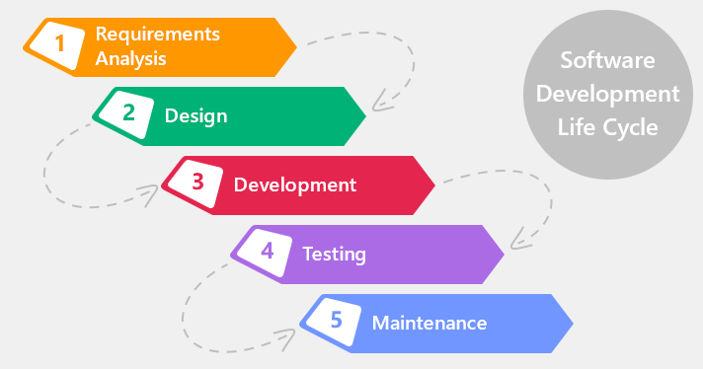

Lecture 2

https://www.howtogeek.com/168896/10-useful-windows-commands-you-should-know/